**Exercise 2: Association Rule Mining**



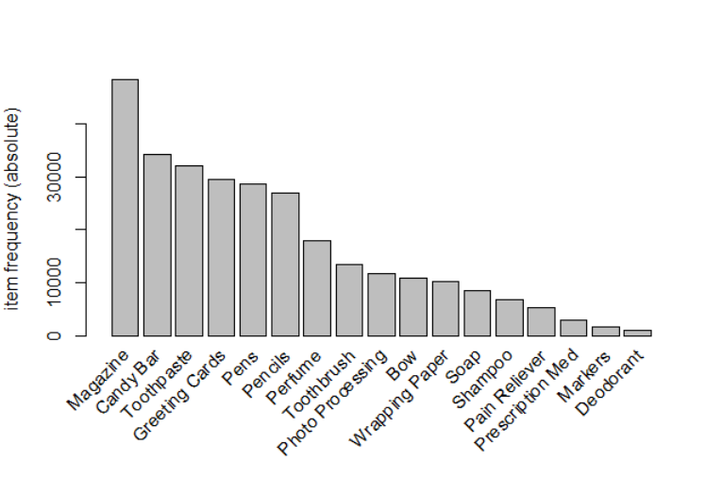

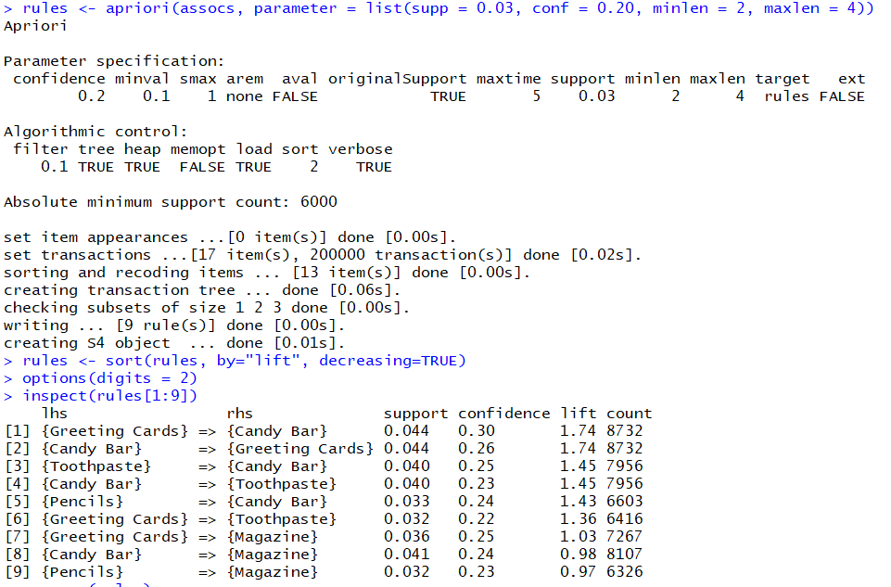

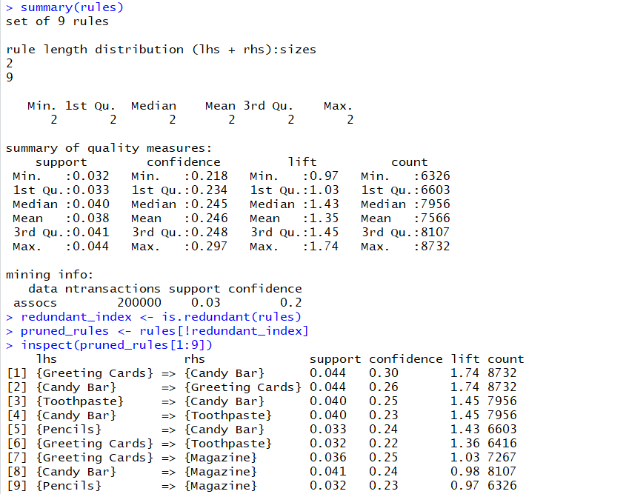

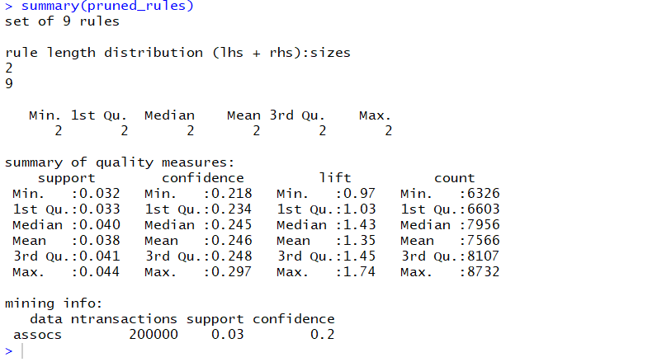

2.a)

Highest lift value in the resulting rules is 1.74 for rules involving Greeting cards and Candy Bar.

2b)

Lift ratio is used to judge the strength of the association rule. Here we consider transactions where consequent is independent of the antecedent. A lift ratio greater than 1 means that the rule has some meaning to it and is useful. It is calculated by using the below formula:

Lift ratio = confidence/ benchmark confidence

Benchmark confidence = no.of transactions with consequent items/ no. of transactions in database

2c)

Association rules are mainly used in marketing to combine the products which are frequently bought together. According to our analysis, we see that if someone bought greeting cards also bought candy bars and person who bought candy bars bought greeting cards as well. This study of associations helps the industry to club products that are frequently sold together and study the customer behavior.

The third rule shows that people who bought toothpaste got candy bars as well and all those who bought candy bars bought toothpaste. The fifth rule shows that people who bought pencils also bought candy bars.

2d)

Studying the first 9 association rules we find that the lift ratios for 2 pairs of same products is equal with the product sides interchanged and they have the highest and second highest lift ratioss For 2 rules we see that the lift value is less than 1 and that makes it difficult for us to know the importance of the rule since the rules with lift ratio greater than 1 has more meaning and strength.

